Remsenburg-Speonk Elementary School
Examples of Class Science Fair Projects 2014
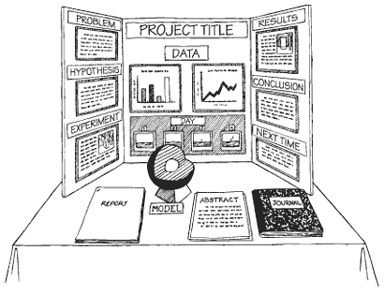
Image from www.4teachers.org

This guide contains examples of past classroom science fair projects. By annually completing a class experiment from Kindergarten through Remsenburg-Speonk graduation, our goal is for students to internalize the scientific process and method of thinking.

All of the following projects were created by students using an inquiry-learning model of instruction and completed during CORE classes, which are team-taught lessons that infuse the classroom curriculum with research and technology.

The projects were developed using the research workbooks available on the school’s Science Fair Webpage. Students then used technologies, such as Graph Club or MS Excel, to analyze the data to help them draw conclusions. The project summary was typed into MS PowerPoint, printed, and then attached to a trifold display board, which was also decorated by the students.

Most importantly, all of the science fair projects followed the 6 steps of the scientific method, which are listed below.

- Testable Question
- Hypothesis
- Materials
- Procedure
- Results
- Conclusion

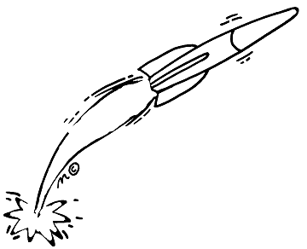
Title: I Love Exercise
Grade: Kindergarten
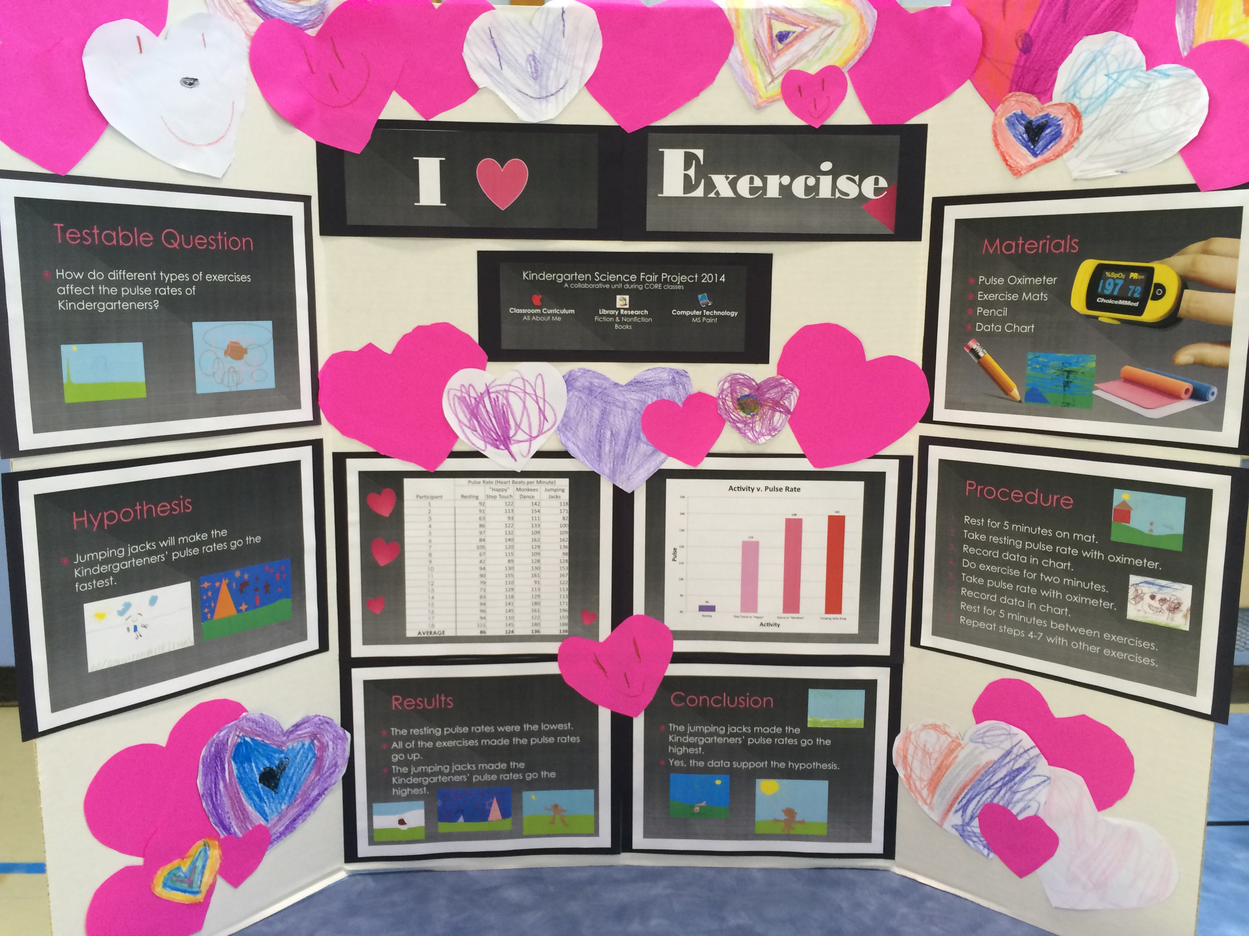

Testable Question:
How do different types of exercises affect the pulse rate of Kindergarteners?

Hypothesis:
Jumping jacks will make the Kindergarteners’ pulse rates go the fastest.

Materials:
Pulse oximeter, exercise mats, pencil, data chart

Procedure:
Rest for 5 minutes on mat. Take resting pulse rate with oximeter. Record data in chart. Do exercise for two minutes. Take pulse rate with oximeter. Record data in chart. Rest for five minutes between exercises. Repeat steps 4-7 with other exercises.

Results:
The resting pulse rates were the lowest. All of the exercises made the pulse rates go up. The jumping jacks made the Kindergarteners’ pulse rates go the highest.

Conclusion:
The jumping jacks made the Kindergarteners’ pulse rates go the highest. Yes, the data support the hypothesis.
Title: Wildlife Window
Grade: 1
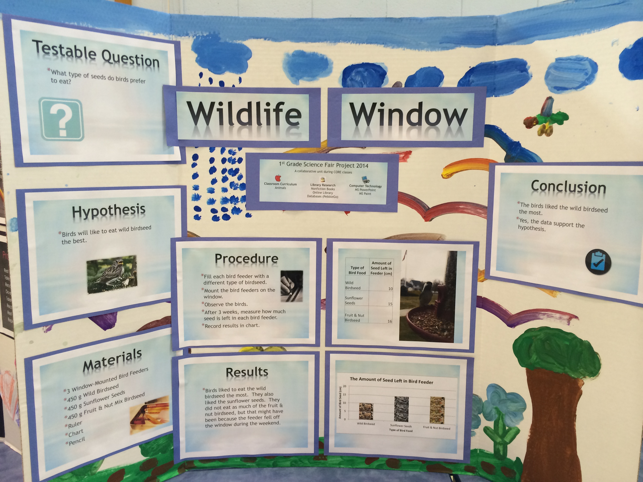
Testable Question:
Why type of seeds do birds prefer to eat?

Hypothesis:
Birds will like to eat wild birdseed the best.

Materials:
3 Window-mounted bird feeders, 450g wild birdseed, 450g sunflower seeds, 450g fruit & nut mix birdseed, ruler, chart, pencil

Procedure:
Fill each bird feeder with a different type of birdseed. Mount the bird feeders on the window. Observe the birds. After 3 weeks, measure how much seed is left in each bird feeder. Record results in chart.

Results:
Birds liked to eat the wild birdseed the most. They also liked the sunflower seeds. They did not eat as much of the fruit & nut birdseed, but that might have been because the feeder fell off the window during the weekend.

Conclusion:
Birds liked to eat the wild birdseed the most. Yes, the data support the hypothesis.
Title: Power Plants
Grade: 2
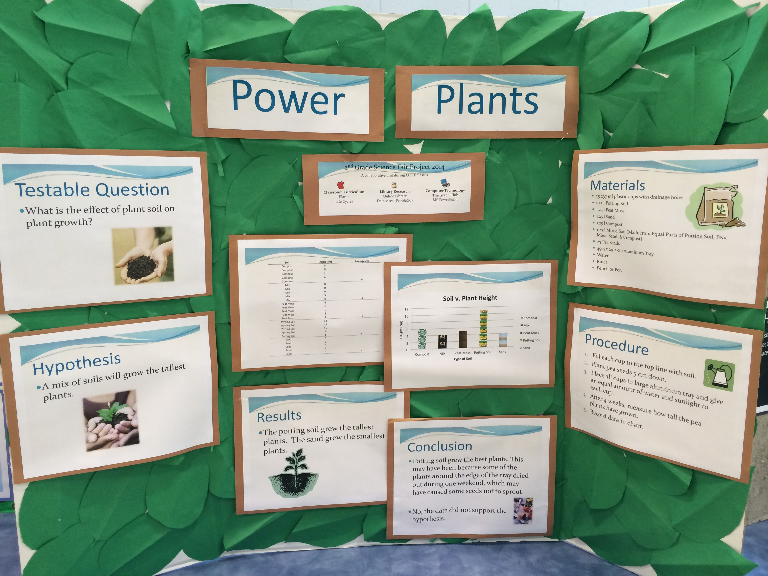
Testable Question:
What is the effect of plant soil on plant growth?

Hypothesis:
A mix of soils will grow the tallest plants.

Materials:
35 plastic cups with drainage holes; 1.25 l each of potting soil, peat moss, sand, compost, and mix; 25 pea seeds; 49.5 x 29.2 cm aluminum tray; water; ruler; pencil or pen.

Procedure:
Fill each cup to the top line with soil. Place pea seeds 5 cm down. Place all cups in large aluminum tray and give an equal amount of water and sunlight to each cup. After 4 weeks, measure how tall the pea plants have grown. Record data in chart.

Results:
The potting soil grew the tallest plants. The sand grew the smallest plants.

Conclusion:
Potting soil grew the best plants. This may have been because some of the plants around the edge of the tray dried out during one weekend, which may have caused some seeds not to sprout. No, the data did not support the hypothesis.
Title: Later Crater
Grade: 3
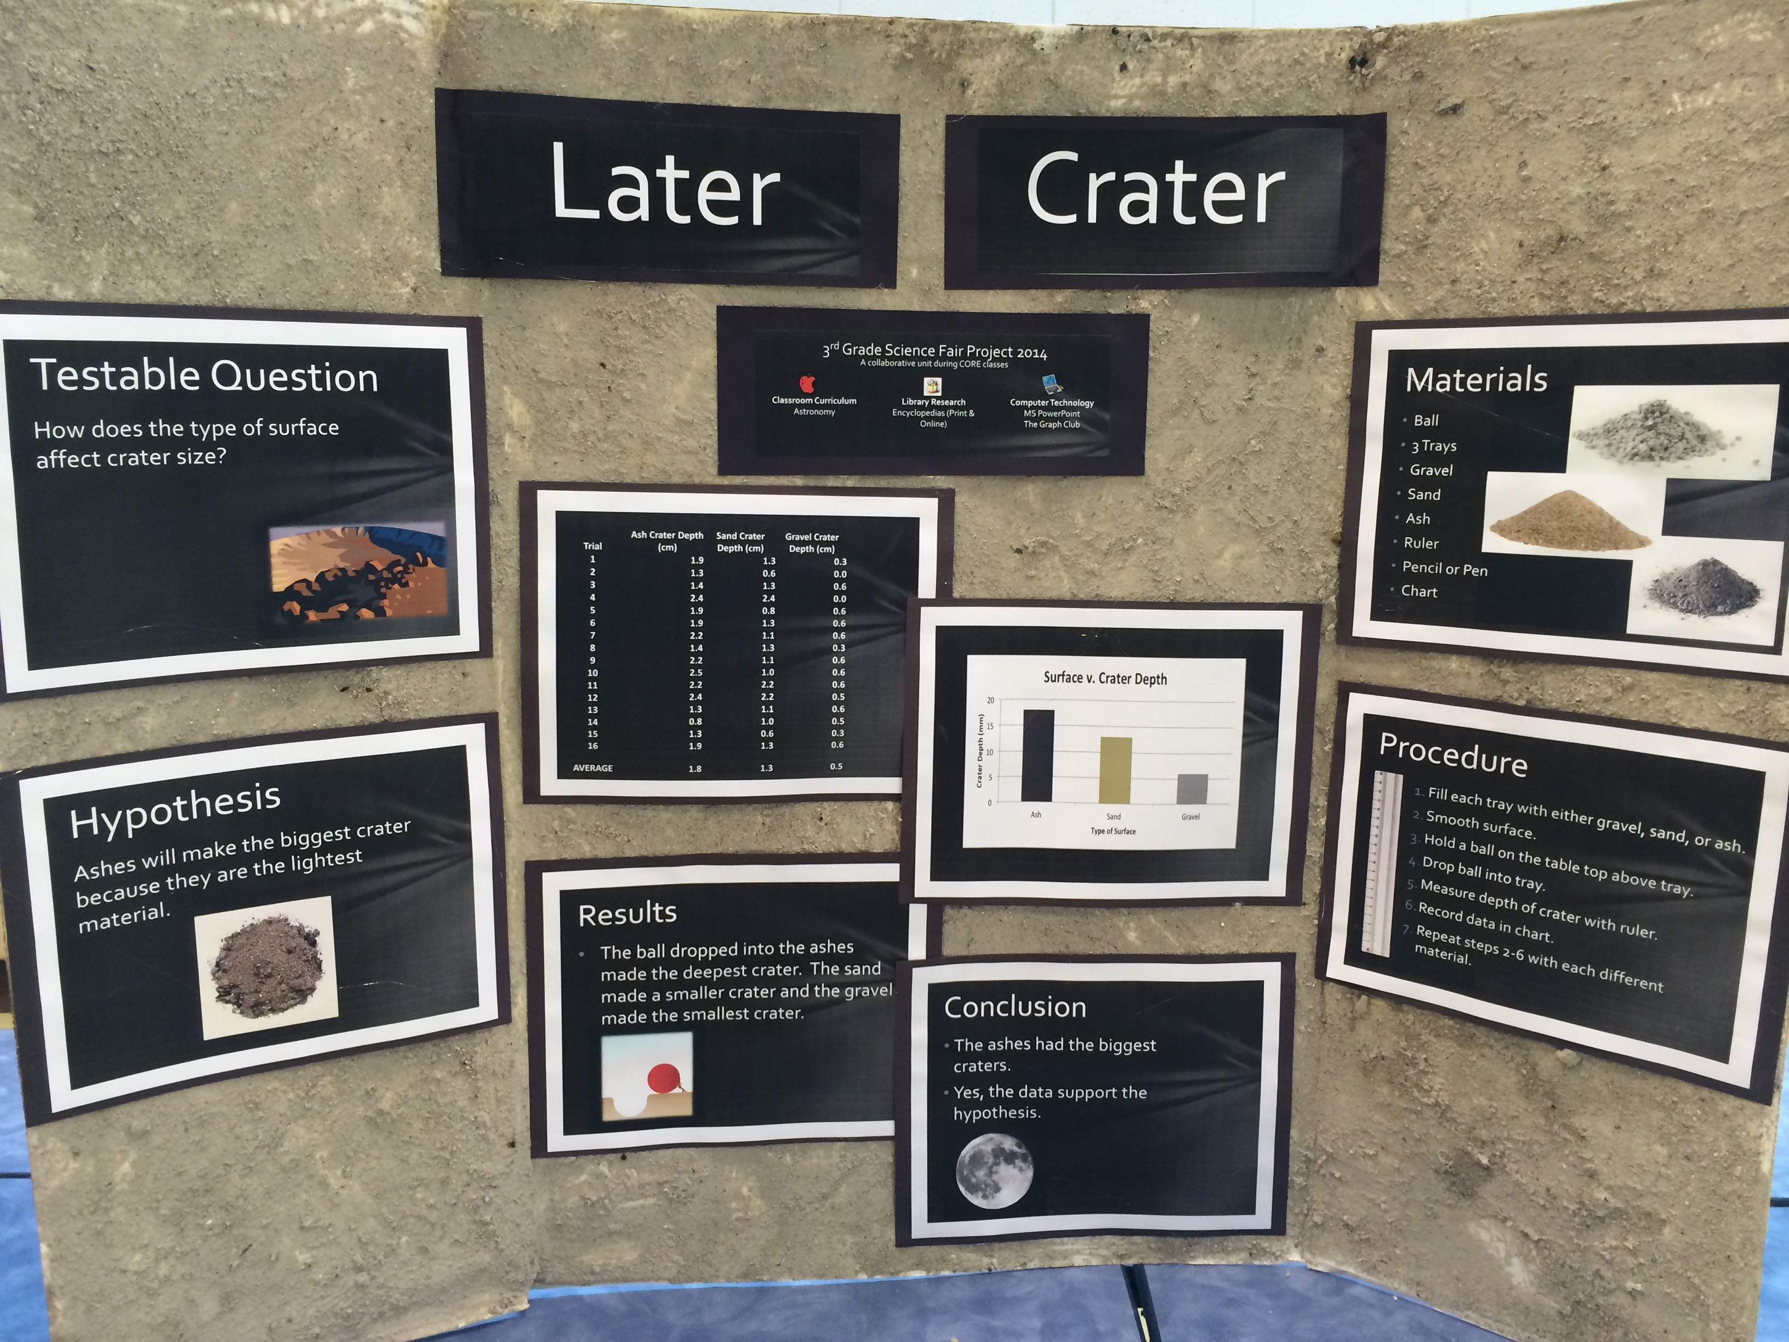

Testable Question:
How does the type of surface affect crater size?

Hypothesis:
Ashes will make the biggest crater because they are the lightest material.

Materials:
Ball, 3 trays, gravel, sand, ash, ruler, pencil or pen, chart

Procedure:
Fill each tray with either gravel, sand, or ash. Smooth surface. Hold ball on the table top above tray. Drop ball into tray. Measure depth of crater with ruler. Record data chart. Repeat steps 2-6 with each different material.

Results:
The ball dropped into the ashes made the deepest crater. The sand made a smaller crater and the gravel made the smallest crater.

Conclusion:
The ashes had the biggest craters. Yes, the data support the hypothesis.

Title: Dropping the Ball
Grade: 4
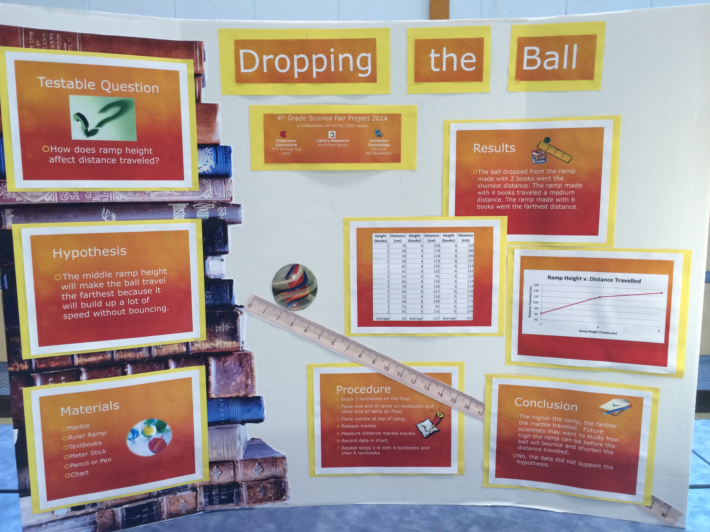
Testable Question:
How does ramp height affect distance traveled?

Hypothesis:
The middle ramp height will make the ball travel the farthest because it will build up a lot of speed without bouncing.

Materials:
Marble, ruler ramp, textbooks, meter stick, pencil or pen, chart

Procedure:
Stack three textbooks on the floor. Place one end of ramp on the textbooks and the other end of ramp on floor. Place marble at top of ramp. Release marble. Measure distance marble travels. Record data in chart. Repeat steps 1-6 with 4 textbooks and then 6 textbooks.

Results:
The ball dropped from the ramp made with 2 books went the shortest distance. The ramp made with 4 books traveled a medium distance. The ramp made with 6 books went the farthest distance.

Conclusion:
The higher the ramp, the farther the marble traveled. Future scientists may want to study how high the ramp can be before the ball will bounce and shorten the distance traveled.
Title: Victory Sprouts
Grade: 5
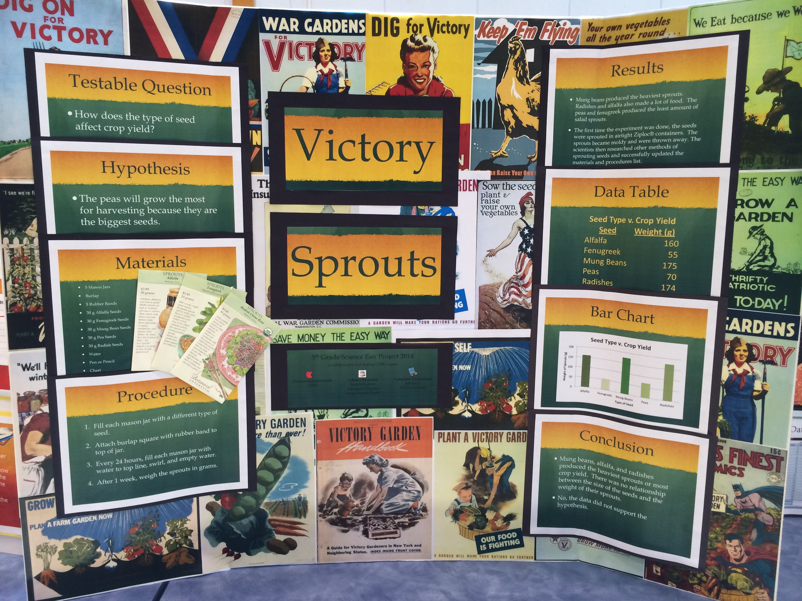
Testable Question:
How does the type of seed affect crop yield?

Hypothesis:
The peas will grow the most for harvesting because they are the biggest seeds.

Materials:
5 Mason jars, burlap, 5 rubber bands, 30 g each of alfalfa, fenugreek, mung beans, peas, and radish seeds, water, pen or pencil, chart

Procedure:
Fill each mason jar with a different type of seed. Attach burlap square with rubber band to top of jar. Every 24 hours, fill each mason jar with water to top line, swirl, and empty water. After 1 week, weigh the sprouts in grams.

Results:
Mung beans produced the heaviest sprouts. Radishes and alfalfa also made a lot of food. The peas and fenugreek produced the least amount of salad sprouts.

Conclusion:
Mung beans, alfalfa, and radishes produced the heaviest sprouts or most crop yield. There was no relationship between the size of the seeds and the weight of their sprouts. No, the data did not support the hypothesis.
Title: Javelins Away
Grade: 6
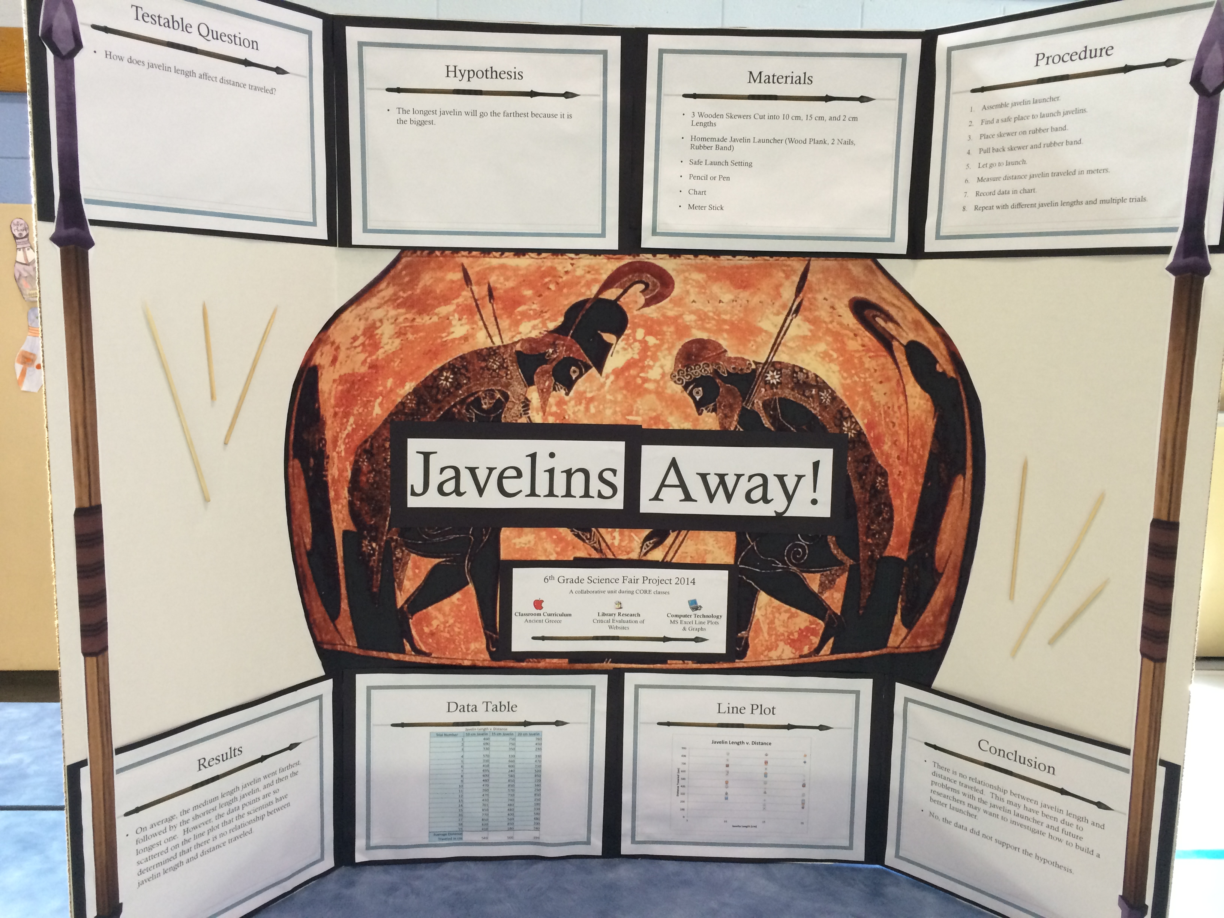
Testable Question:
How does javelin length affect distance traveled?

Hypothesis:
The longest javelin will go the farthest distance because it is the biggest.

Materials:
3 Wooden skewers cut into 10 cm, 15 cm, and 20 cm lengths, homemade javelin launcher (wood plank, 2 nails, rubber band), safe launch setting, pencil or pen, chart, meter stick

Procedure:
Assemble javelin launcher. Find a safe place to launch javelins. Place skewer on rubber band. Pull back skewer and rubber band. Let go to launch. Measure distance javelin traveled in meters. Record data in chart. Repeat with different javelins lengths and multiple trials.

Results:
On average, the medium length javelin went the farthest, followed by the shortest length javelin, and then the longest. However, the data points are so scattered on the line plot that the scientists have determined that there is no relationship between javelin length and distance traveled.

Conclusion:
There is no relationship between javelin length and distance traveled. This may have been due to problems with the javelin launcher and future researchers may want to investigate how to build a better launcher. No, the data did not support the hypothesis.

